Lab 6: CNN Modeling Technical Document

Name: Peter Nguyen

Group Members: Ronald, Sunny, Glenn

Instructor Chris Pham

EE 104: Applied Programming in EE

Due Date: 04/09/2023

Table of Contents

**YouTube Links** 3

Github Links 4

Project Description 5

CNN - Baseline + Increasing Dropout… 6

Source Code 6

Console Output 7

Plots 9

CNN - Challenge Test 10

Source Code 10

Console Output 11

Plots 11

Game Development – Flight 14

Source Code 14

Console Output 17

Game Window 18

Hello World to OpenAi 21

Source Code 21

Website 22

Hello World to ChatGPT 23

Source Code 23

Console Output 23

Parameter Observation 24

# **YouTube Links**

**CNN - Baseline + Increasing Dropout...:**

<https://youtu.be/KIfEtm1YMmk>

**CNN - Challenge test:**

<https://youtu.be/XnGNs8IsQXs>

**Game Development - Flight:**

<https://youtu.be/OfCBoZFie6c>

**Hello World to OpenAI:**

<https://youtu.be/nIftmuTB_4E>

**Hello World to CHATGPT:**

<https://youtu.be/oIhCTpA70Ck>

# **Github Links**

CNN

<https://github.com/DisplayNameSir/CNN>

Happy Garden Game

<https://github.com/DisplayNameSir/Happy-Garden-Game>

Hello World and Intro to OpenAI

<https://github.com/DisplayNameSir/Intro-to-OpenAI>

# Project Description

Part 1: CNN - Baseline + Increasing Drop... - This lab involves training a Convolutional Neural Network (CNN) to recognize and classify images using machine learning. The program is modified from MIT's code and run for over 210 epochs to train the AI. The resulting data is then used to verify the accuracy of the AI's ability to recognize and classify images.

Part 2: CNN - Challenge Test - In this lab, the CNN generated from the previous lab is put to the test using a challenge test. The AI is expected to accurately identify and classify images based on the data it was trained on.

Part 3: Game Development - Flight - This lab involves modifying an existing video game called Happy Garden to increase its difficulty. Students add additional challenges, such as Fang Flowers, wilted flowers, and rain, to make the game more difficult to play.

Part 4: Hello World to Openai - This lab introduces students to using OpenAI or ChatGPT to create an HTML website that generates funny nicknames. The program is run in Anaconda Powershell Prompt and the resulting website is hosted on a local host for users to access.

Part 5: Hello World to ChatGPT - This lab explores the different parameters that can be used to customize and define the responses generated by ChatGPT. Students modify the parameters and compare the resulting outputs to better understand how the AI generates its responses.

# **CNN - Baseline + Increasing Dropout…**

## Source Code

## Console Output

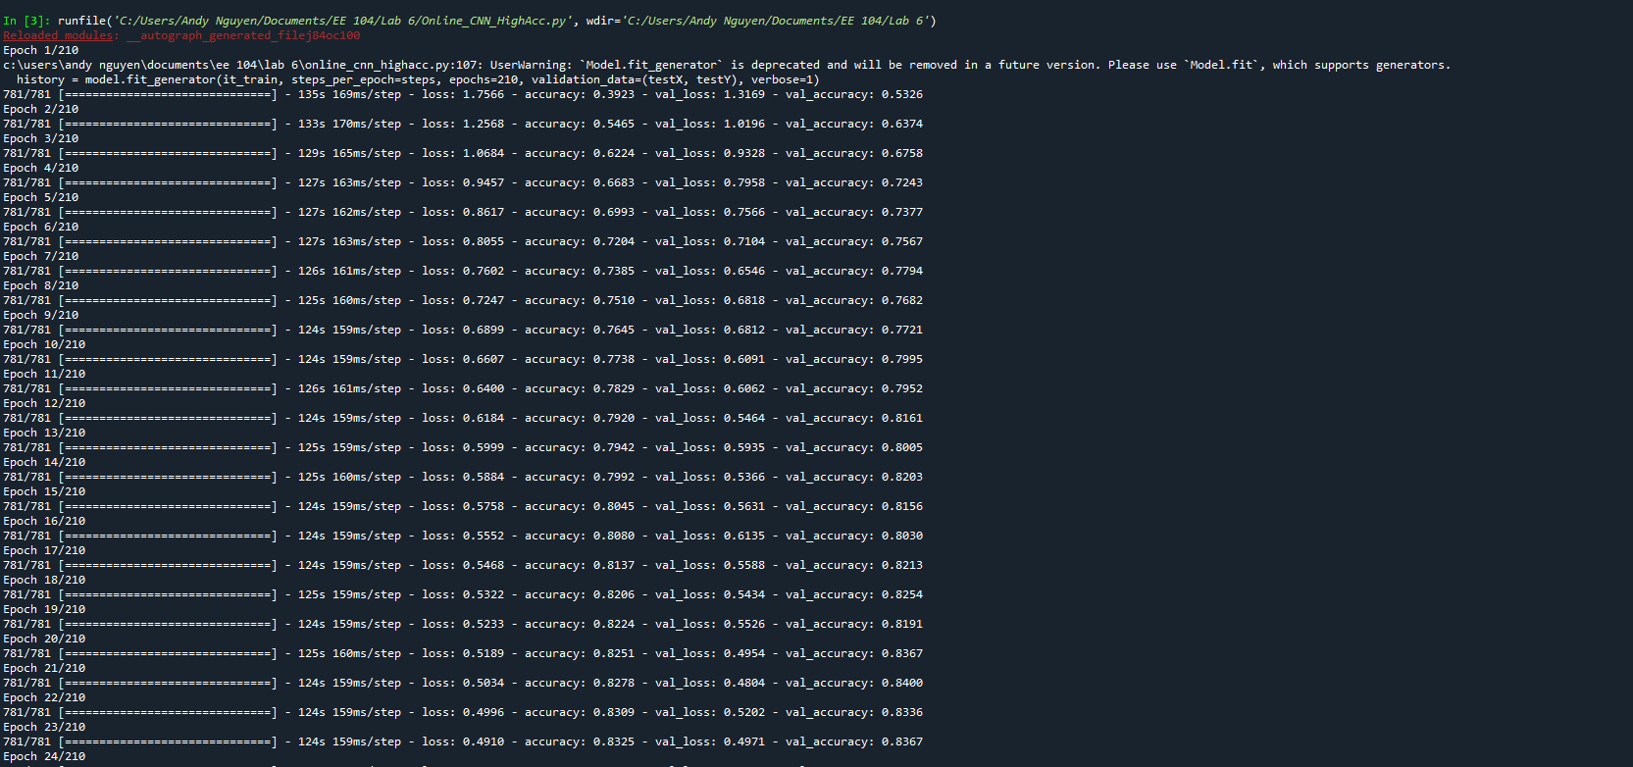

## Plots

# CNN - Challenge Test

## Source Code

## Console Output

## Plots

# Game Development – Flight

## Source Code

## Console Output

## Game Window

# Hello World to OpenAi

## Source Code

## Website

# Hello World to ChatGPT

## Source Code

## Console Output

## Parameter Observation

Engine - The engine parameter allows the program to use different Chatgpt engines, each with its own benefits and disadvantages depending on the usage of the AI.

Prompt - The prompt parameter specifies the starting text for the language model to generate the response. By modifying the prompt parameter, users can create a more personalized starting message for the chatbot.

Max_tokens - The max_tokens parameter specifies the maximum number of tokens that the language model can generate in the response. By adjusting this value, users can control the length of the responses generated by the AI.

n - The n parameter specifies the number of responses to generate. By increasing the value of n, users can get more detailed responses, but at the cost of longer response times.

Stop - The stop parameter is a string used to ask users additional questions or quickly cancel the program. It can also be used to gather feedback from users after the AI answers a question.

Temperature - The temperature parameter controls the creativity of the responses generated by the AI. Higher values lead to more unpredictable and creative responses, while lower values result in more straightforward and concise answers.